 2025
NAME:

ALGORITHMICS UNIT 4
SAC 3: Computer Science, past and present
Unit 4 Outcome 3

Date of Completion: 6-10 October 2025

Reading Time: 5 minutes
Writing time: 55 minutes
TOTAL: 60 minutes

QUESTION AND ANSWER BOOK

Type | Number of  questions | Number of questions  to be answered | Number of marks
Short/Extended Response | 8 | 8 | 25
 |  | Total | 25

Materials supplied
Question and answer book of 7 pages
Materials permitted
Pens/Stationary
No calculator or reference material permitted.

Student declaration: This SAC is my own work and has been completed according to the stated requirements.

Signed:……………………………………………………………………………..

1. Calculate the activation value for neuron o₁, given that i₁ = 1 and i₂ = 4.
i₁
2
o₁

3
i₂₂

(1 mark)

2. Describe two reasons for the resurgence of neural networks in the late 20th century.
e.g.
More data
More computing power
Better understanding of the brain
Development of backpropagation algorithm
1m each for short description.

(2 marks)

3.
(a) Describe the criteria for a machine to pass the Turing test.
A person cannot distinguish the outputs from a computer and a human in normal conversation.
(1 mark)

(b) Explain whether or not passing the Turing test implies that we have created Strong AI.
No – strong AI means that the computer is genuinely thinking/understanding/conscious, but we have just developed something which mimics thought.
(2 marks)
4.
(a)
“The Halting Problem only applies for a very specific, artificially constructed example. It doesn’t show any meaningful boundaries on computing power.” Give an argument explaining why this view is incorrect.
If we want to prove that computers can solve any problem, we only have to find one problem that can’t be solved in order to refute this. Also, there are other problems which can be reduced to the HP, such as busy beaver.
(2 marks)

(b)
“I’ve written a program which is 100% hacker proof.” Explain, with reference to concepts from the course, why this is impossible to guarantee.
It’s impossible to write a program which can test any given program to check that it is hacker proof, due to the uncertainty/undecidability introduced by HP.
(Note that this does not mean we can’t individually determine that a simple program might be hacker proof, just that we can’t develop a system which checks all programs. However there are further reasons to doubt that even simple programs can be proved safe)
(2 marks)

5. Compare overfitting and underfitting by SVMs by discussing how well they fit training data and unseen data.
Overfitting fits training data well, underfitting does not. (Overfitting captures all the noise and arbitrary patterns of training data which do not necessarily translate to the real world; underfitting does not properly capture the patterns in the data at all.)
Both perform poorly on unseen data.

(3 marks)

6.
(a)
“This data is not linearly separable because you can’t draw a line through it to separate it.” Explain whether or not this is correct.
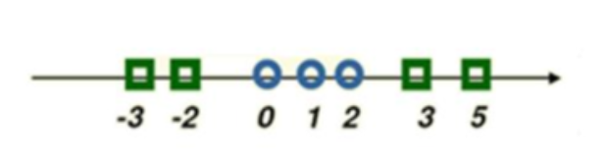
Yes, you can apply a quadratic transformation to make the data linearly separable using a straight line.

(2 marks)
(b)
“This data is too mixed up, you can’t draw a plane between the orange and blue points which means it can’t be linearly separable.” Explain whether or not this is correct.
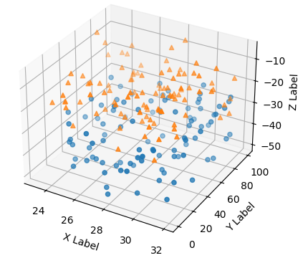
It can be separated into further dimensions (> 3) which can then be separated with a hyperplane. (in fact all data can be made separable by giving each data point its own dimension, unless you have two identical data points with different labels.)

(2 marks)
7.
(a) Searle’s Chinese Room Argument asks us to consider a man in a room who interprets Chinese characters so that his responses appear to be those of a Chinese speaker, however, he does not understand the language. What point is Searle trying to make with this argument?

Strong AI is impossible, all the computer is doing is copying the Chinese room, creating the illusion of thought but with no actual semantic understanding.

(2 marks)
(b) Compare the robot response with the systems response, clearly stating one similarity and one difference.

Similarity – both consider the robot/system as having understanding as a whole
Difference – robot takes sensory input from real world
(2 marks)

8. The army has developed an app for deciding who to treat first in a mass-casualty situation. A medic enters the injuries and vital signs (heart rate, blood pressure etc.) of a casualty, and the app uses a neural network to work out what resources should be allocated to this casualty compared to other casualties.
Discuss whether or not this is better than letting medics decide for themselves how to allocate resources among patients. Your answer should consider transparency, bias, fairness and human dignity. (Do not consider the privacy or technical aspects of this problem.)
Many discussion points available around the following ideas:
Transparency – need to know how it decides who lives
Bias – based on previous health data, but if the demographic or medical technology changes it may no longer be accurate
Accountability – if it makes a bad decision, should the army/medic/developer be responsible?
Human dignity – we feel it’s a decision that a human should make, even if it’s imperfect.

(5 marks)

